Software Packages:
- matplotlib.pyplot : it’s a collection of functions that make matplotlib work like MATLAB . we use its functions to plot pearsons correlation coefficient like plot.scatter(x,y) , plot.show().
Steps:
- we iterate over the filtered dataframes to calculate each r (correlation coefficient) of every gene in our data.
- We store these coefficients in a list, then we add this list as a column in the filtered dataframes.
- We now sort these dataframes according to the column (r or CC).
- We then get the highest positive CC and the lowest negative CC and the names of these two genes and this satisfies the first requirement.
- Then we plot the expression levels of the above two genes in 2 graphs one for each gene in healthy and cancer fataframes using our matplotlib package.
Results & Discussion:
- We first read the data of healthy and cancerous genes and convert them to dataframes using pandas package.

- We start by filtering our dataframes from all the rows that has more than 25 zeros as these values doesn’t make sense and give us unwanted or weird results. We do this by dropping all the rows we find in the healthy genes from both dataframes health and cancer, then we drop the rows that has the same condition we find in the cancerous one from both dataframes health and cancer.

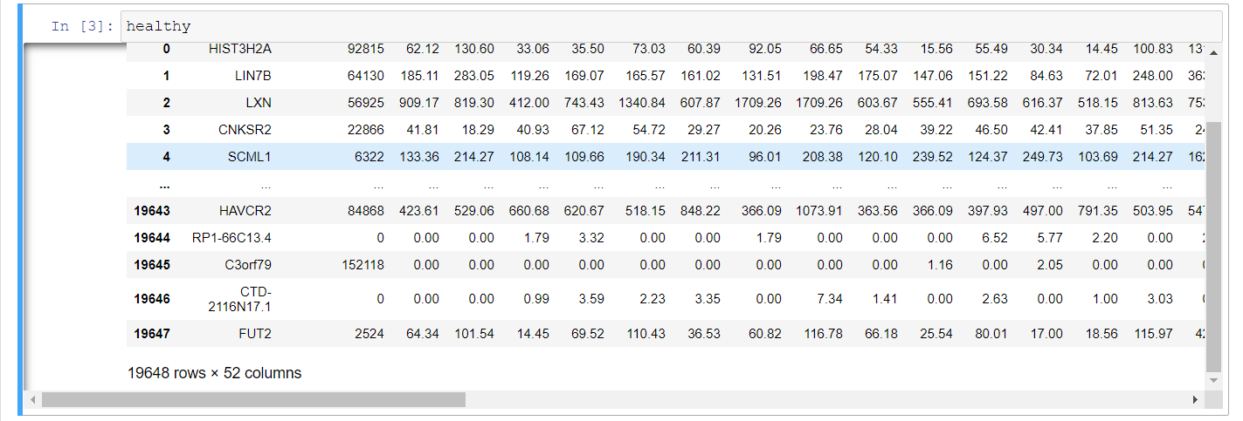
Original Health Genes Dataframe
In here we have 19648 rows × 52 columns
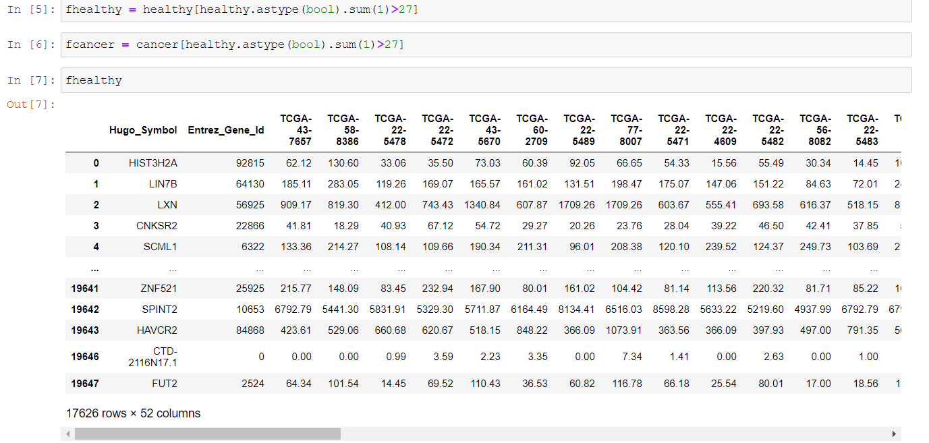
First filtration of Health Genes Dataframe
After this stage we can see we now have 17626 rows × 52 columns
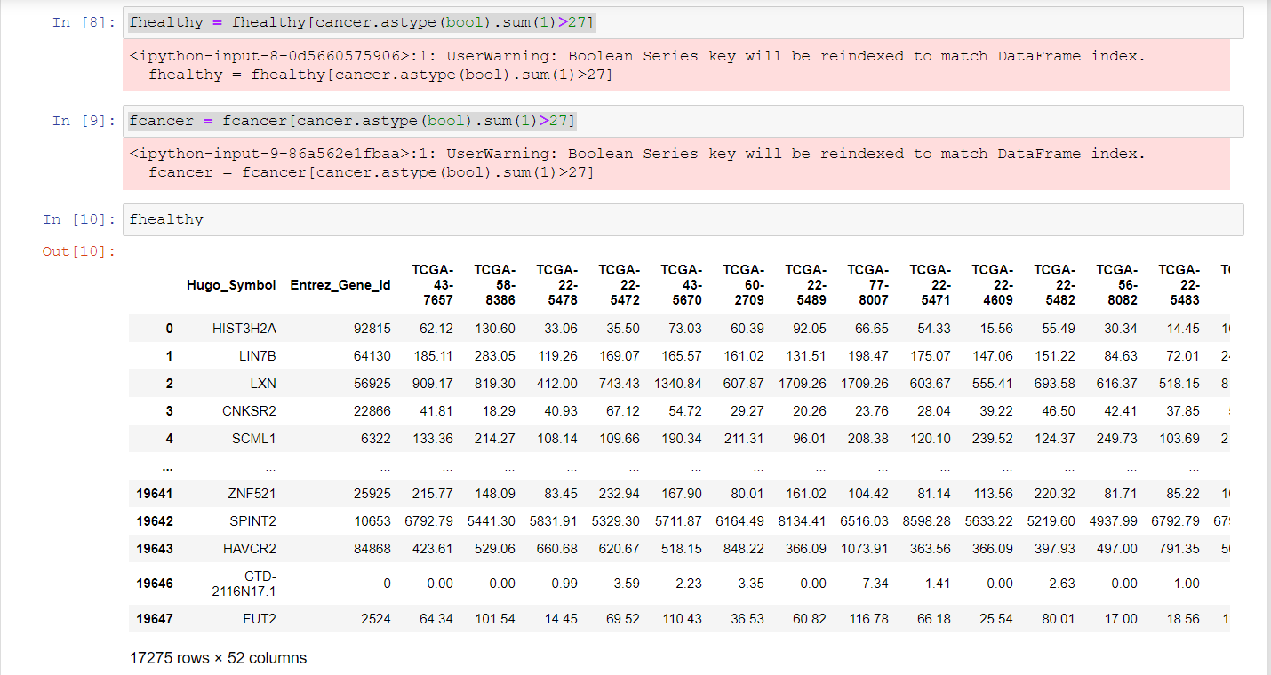
second filtration of Health Genes Dataframe

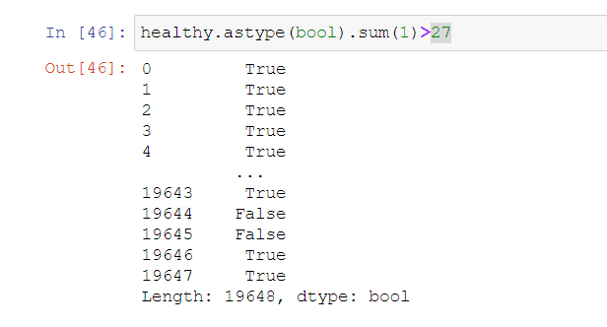
- After this stage we can see we now have 17275 rows × 52 columns. So now we don’t have any row that has more than 25 zeros and so we expect a more accurate calculation. This function returns in the index of the row false if there was more than 25 zeros and true if otherwise like we see next.

- Now we want to figure out the relation between every gene expression in the 2 cases (healthy, cancer) so we want to calculate the CC (correlation coefficient) for each gene to know how each gene contribute in this cancer disease. So we make an empty list and fill it with every CC of each gene.

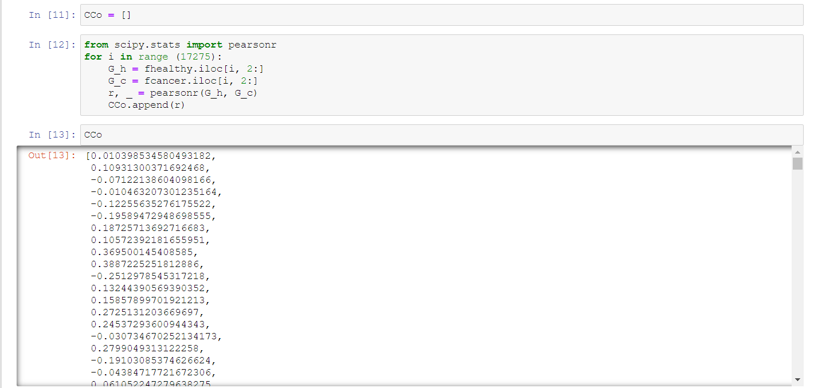

- We want to rank genes based on their correlation coefficient (CC) , so we add CC list as a column in both dataframes the we sort our data frames ascendingly according to CC column.
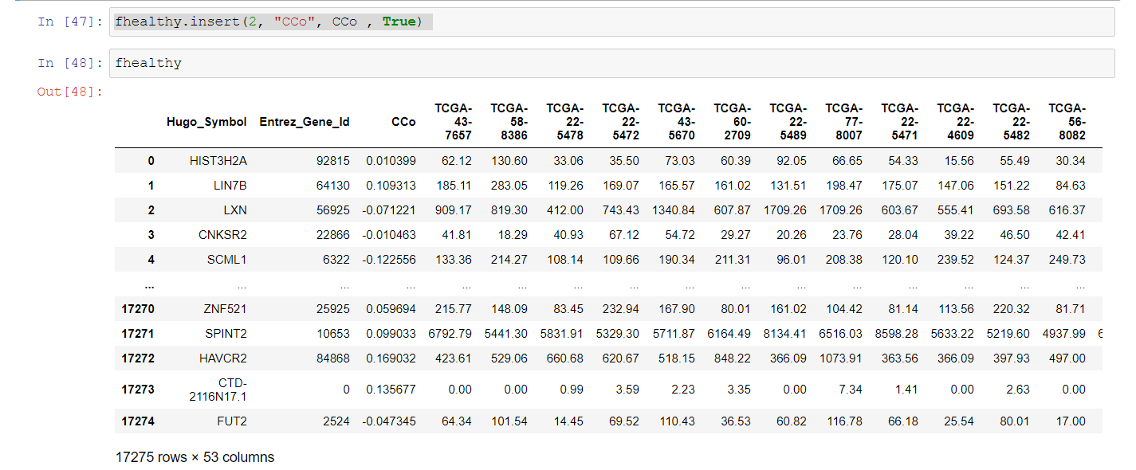

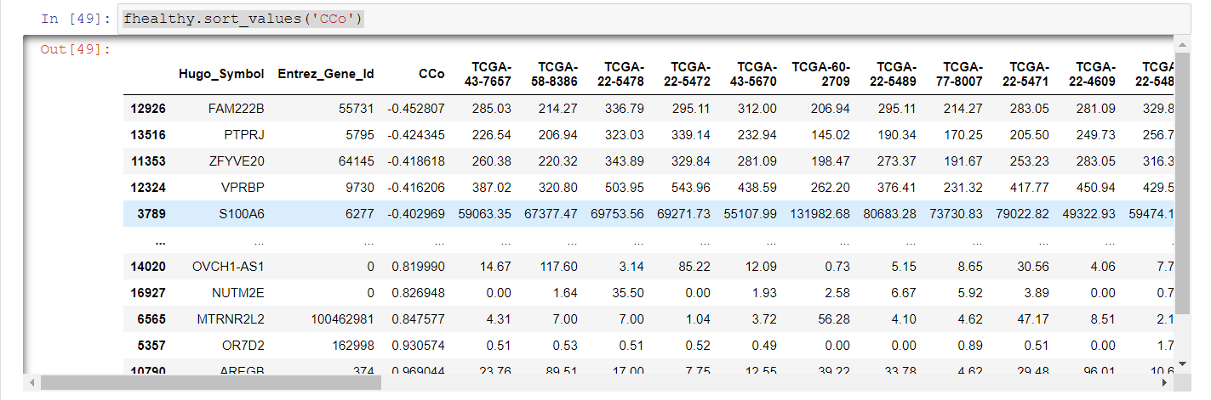
this dataframe can be found in ranked_healthy.csv

- Then we can detect the highest positive CC and the lowest negative CC and the names of these two genes.
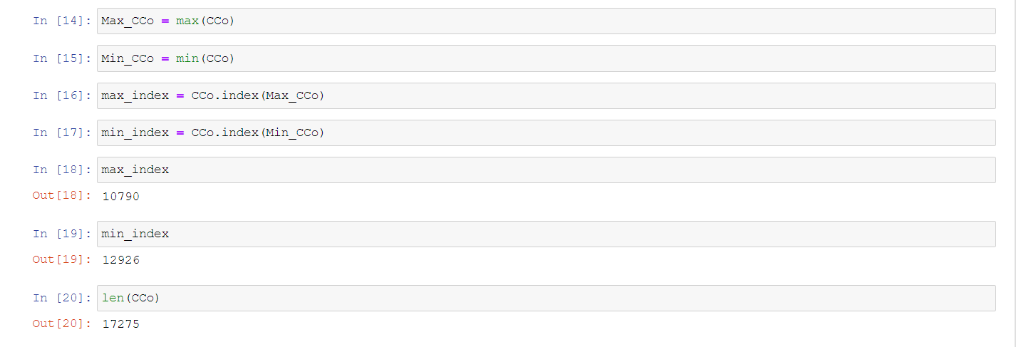
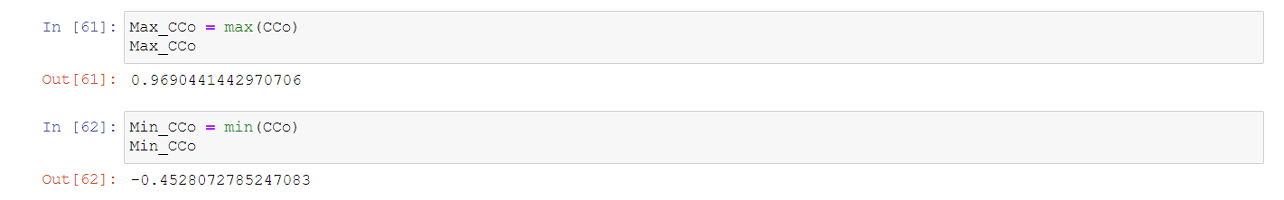
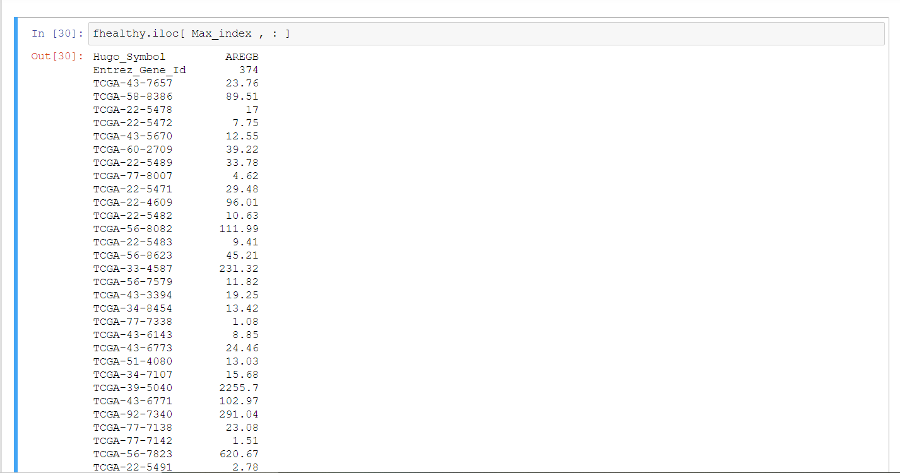
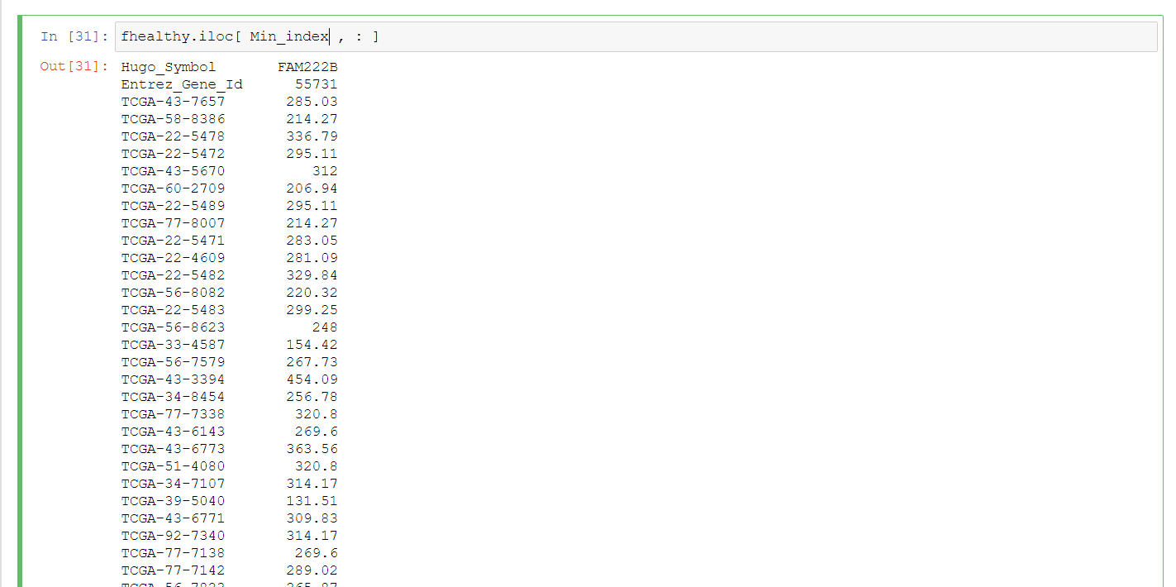

- From here we can figure out that highest +ve CC = 0.969044 & lowest -ve CC = -0.452807 with Genes names as : AREGB , FAM222B Consecutively.
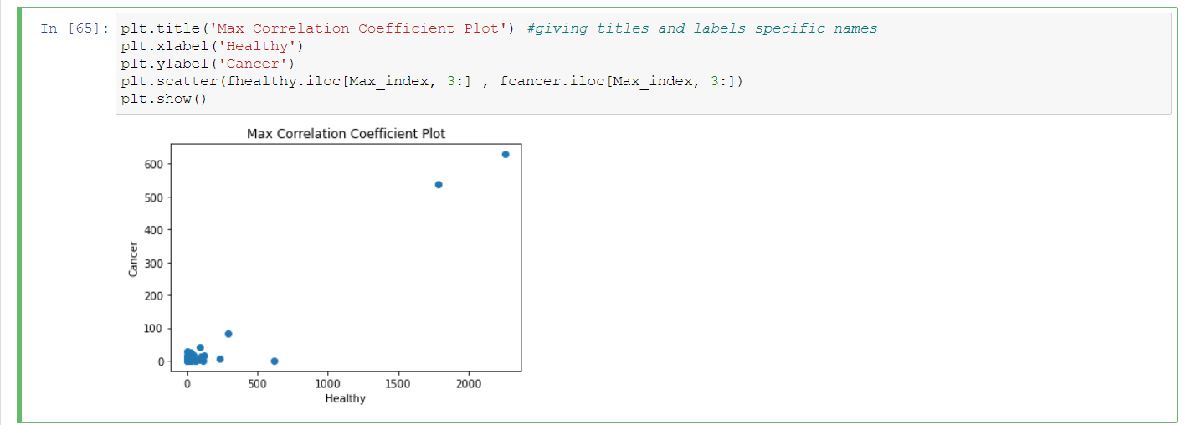
- Now we want to plot these 2 genes in 2 graphs. We first take the gene that has the highest +ve CC between its Healthy gene expressions on the X-axis and cancer gene expressions on the y-axis and plot this graph using plot.scatter ,then we do the same thing for the gene that has the lowest -ve CC.
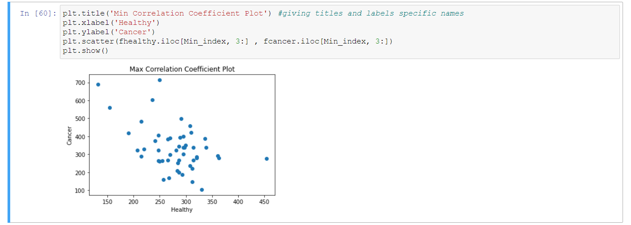

Conclusion:
Correlation coefficient formulas are used to find how strong a relationship is between each gene in dataframe It shows the linear relationship between two sets of data. In simple terms, it answers the question, Can I draw a line graph to represent the data?. The formulas return a value between -1 and 1, where:

1 indicates a strong positive relationship.
-1 indicates a strong negative relationship.
A result of zero indicates no relationship at all.
So AREGB gene has the strongest positive relationship which means that it’s not responsible for the cancer disease, and FAM222B has the lowest negative relationship which means that it highly contributes in the presence of this disease.
We can also figure out this conclusion from the graphs we plotted. In the plot of the highest +ve CC we can find that the best fit line would have a positive slope which means we have strong positive relationship (CC between 0 and 1) between health and cancerous gene, also we can see that all the data of gene expressions are so close to the fit line more than any other gene and not too scattered and this is why this gene has the highest CC because as we know the more the scattering along y-axis compared to scattering along x-axis the stronger the relationship is.
In the plot of the highest -ve CC we can find that the best fit line would have a negative slope which means we have strong negative relationship (CC between 0 and -1) between health and cancerous gene, also we can see that all the data of gene expressions are scattered around the fit line more than any other gene and not too close and this is why this gene has the lowest CC because as we know the more the scattering along the x-axis compared to scattering along y-axis the inversely stronger the relationship is.
In both cases we drew the healthy gene expressions (as it’s considered the predictor) along x-axis and the cancerous gene expressions (the response) along y-axis.
Introduction:
The correlation coefficient is a statistical measure of the strength of the relationship between the relative movements of two variables. The values range between -1.0 and 1.0. A calculated number greater than 1.0 or less than -1.0 means that there was an error in the correlation measurement. So, we want to know How likely is the relationship between the two dataframes of healthy and cancerous genes to be linear and which gene expressions that associate highly in the precedence of the disease and how strong their relationship is and it’s direction (+ve or -ve), So we’re going to calculate and plot all CC’s to answer these questions.

